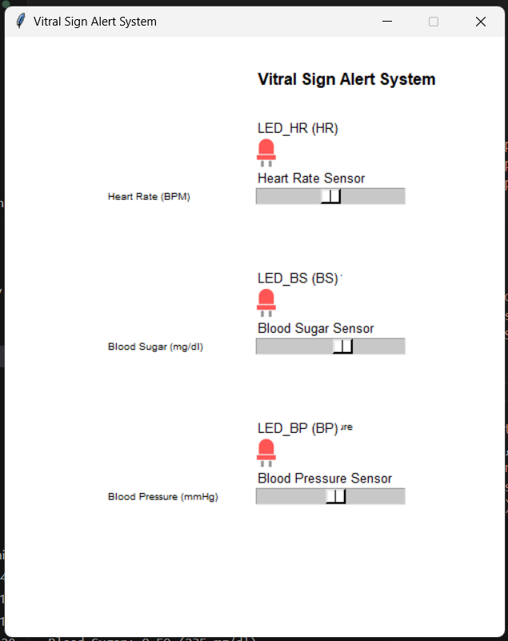
email_sending.py
import smtplib
import email.mime.multipart
from email.mime.text import MIMEText

user_name = "Thanawat Lhuangwirot"
user_email = 'thanawatlhuangwirot@gmail.com'
gmail_password = 'pjaw cufa bgax xfqj'
target_name = "Thanawat Lhuangwirot"
target_email = "thanawat.lue@gpo.or.th"
message = "This is the body of the Email Test message."

def send_email(user_name, user_email, gmail_password, target_name, target_email, message):

try:
msg = email.mime.multipart.MIMEMultipart()
msg['to'] = f'{target_name}<{target_email}>'
msg['from'] = f'{user_name}<{user_email}>'
msg['subject'] = 'Email Test'
msg.add_header('reply-to', user_email)
msg.attach(MIMEText(message, 'plain'))
session = smtplib.SMTP('smtp.gmail.com', 587)
session.starttls()
session.login(user_email, gmail_password)
message = msg.as_string()
session.sendmail(user_email, target_email, message)
session.quit()
print('Email sent.')
except Exception as e:
print('Email failed to send.')
print(e)

# send_email(user_name, user_email, gmail_password, target_name, target_email, message)

vitral_sign.py
from gpiozero import Servo, MCP3008, Button, LED, Buzzer
from time import sleep
import signal
from email_sending import send_email

user_name = "Thanawat Lhuangwirot"
user_email = 'thanawatlhuangwirot@gmail.com'
gmail_password = 'pjaw cufa bgax xfqj'
target_name = "Thanawat Lhuangwirot"
target_email = "thanawat.lue@gpo.or.th"

print("Vitral Sign Alert System is running...")

led_HeartRate = LED(17)
led_BloodSugar = LED(27)
led_BloodPressure = LED(22)
HeartRate_sensor = MCP3008(channel = 0)
BloodSugar_sensor = MCP3008(channel = 1)
BloodPressure_sensor = MCP3008(channel = 2)

hr_alert_sent = False
bs_alert_sent = False
bp_alert_sent = False

email_cooldown = 120 # ส่งทุกๆ 1 นาที 120 * 0.5

hr_cooldown = 0
bs_cooldown = 0
bp_cooldown = 0

def main():
global hr_alert_sent, bs_alert_sent, bp_alert_sent
global hr_cooldown, bs_cooldown, bp_cooldown

print("System active. Press Ctrl+C to exit.")

while True:
# อัพเดตตัวนับ cooldown
if hr_cooldown > 0:
hr_cooldown -= 1
if bs_cooldown > 0:
bs_cooldown -= 1
if bp_cooldown > 0:
bp_cooldown -= 1

# HeartRate_sensor (if more than 120 bpm, send email notify user, max 300 bpm)
HR = HeartRate_sensor.value
print(f"Heart Rate: {HR:.2f} ({int(HR * 300)} BPM)")

if HR >= 0.4:
led_HeartRate.on()
if not hr_alert_sent and hr_cooldown == 0:
HR_message = f"ALERT: High Heart Rate detected! Current value: {int(HR * 300)} BPM ({HR:.2f})"
send_email(user_name, user_email, gmail_password, target_name, target_email, HR_message)
hr_alert_sent = True
hr_cooldown = email_cooldown
print("Heart Rate alert ")
else:
led_HeartRate.off()
if hr_alert_sent and hr_cooldown == 0:
# HR_normal_message = f"NORMAL: Heart Rate returned to normal: {int(HR * 300)} BPM ({HR:.2f})"
# send_email(user_name, user_email, gmail_password, target_name, target_email, HR_normal_message)
hr_alert_sent = False
hr_cooldown = email_cooldown
# print("Heart Rate normal email sent!")

# BloodSugar_sensor (if more than 200 mg/dl, send email notify user, max 400 mg/dl)
BS = BloodSugar_sensor.value
print(f"Blood Sugar: {BS:.2f} ({int(BS * 400)} mg/dl)")

if BS >= 0.5:
led_BloodSugar.on()
if not bs_alert_sent and bs_cooldown == 0:
BS_message = f"ALERT: High Blood Sugar detected! Current value: {int(BS * 400)} mg/dl ({BS:.2f})"
send_email(user_name, user_email, gmail_password, target_name, target_email, BS_message)
bs_alert_sent = True
bs_cooldown = email_cooldown
print("Blood Sugar alert email sent!")
else:
led_BloodSugar.off()
if bs_alert_sent and bs_cooldown == 0:
# BS_normal_message = f"NORMAL: Blood Sugar returned to normal: {int(BS * 400)} mg/dl ({BS:.2f})"
# send_email(user_name, user_email, gmail_password, target_name, target_email, BS_normal_message)
bs_alert_sent = False
bs_cooldown = email_cooldown
# print("Blood Sugar normal email sent!")

# BloodPressure_sensor (if more than 140 mmHg, send email notify user, for max 300 mmHg)
BP = BloodPressure_sensor.value
print(f"Blood Pressure: {BP:.2f} ({int(BP * 300)} mmHg)")

if BP >= 0.47:
led_BloodPressure.on()
if not bp_alert_sent and bp_cooldown == 0:
BP_message = f"ALERT: High Blood Pressure detected! Current value: {int(BP * 300)} mmHg ({BP:.2f})"
send_email(user_name, user_email, gmail_password, target_name, target_email, BP_message)
bp_alert_sent = True
bp_cooldown = email_cooldown
print("Blood Pressure alert email sent!")
else:
led_BloodPressure.off()
if bp_alert_sent and bp_cooldown == 0:
# BP_normal_message = f"NORMAL: Blood Pressure returned to normal: {int(BP * 300)} mmHg ({BP:.2f})"
# send_email(user_name, user_email, gmail_password, target_name, target_email, BP_normal_message)
bp_alert_sent = False
bp_cooldown = email_cooldown
# print("Blood Pressure normal email sent!")

sleep(0.5)

if __name__ == "__main__":
main()

vitral_sign_simulation.py
from tkgpio import TkCircuit

configuration = {
"name": "Vitral Sign Alert System",
"width": 500,
"height": 600,

"leds": [
{"x": 250, "y": 100, "name": "LED_HR (HR)", "pin": 17},
{"x": 250, "y": 250, "name": "LED_BS (BS)", "pin": 27},
{"x": 250, "y": 400, "name": "LED_BP (BP)", "pin": 22}
],

"adc": {
"mcp_chip": 3008,
"potentiometers": [
{"x": 250, "y": 150, "name": "Heart Rate Sensor", "channel": 0},
{"x": 250, "y": 300, "name": "Blood Sugar Sensor", "channel": 1},
{"x": 250, "y": 450, "name": "Blood Pressure Sensor", "channel": 2}
]
},

"labels": [
{"x": 250, "y": 30, "text": "Vitral Sign Alert System", "font": ("Arial", 16, "bold")},
{"x": 250, "y": 80, "text": "High Heart Rate", "font": ("Arial", 10)},
{"x": 250, "y": 230, "text": "High Blood Sugar", "font": ("Arial", 10)},
{"x": 250, "y": 380, "text": "High Blood Pressure", "font": ("Arial", 10)},
{"x": 100, "y": 150, "text": "Heart Rate (BPM)", "font": ("Arial", 10)},
{"x": 100, "y": 300, "text": "Blood Sugar (mg/dl)", "font": ("Arial", 10)},
{"x": 100, "y": 450, "text": "Blood Pressure (mmHg)", "font": ("Arial", 10)}
]
}

circuit = TkCircuit(configuration)

@circuit.run
def main():
import vitral_sign

vitral_sign.main()

E-mail inbox:
Heart rate
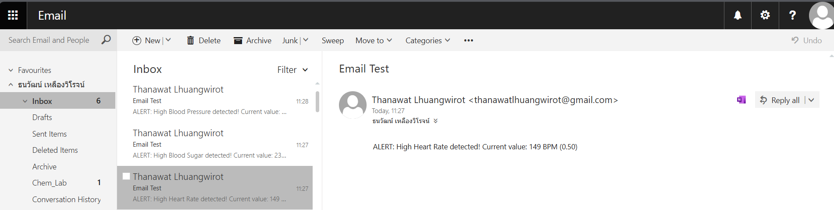
Blood Sugar
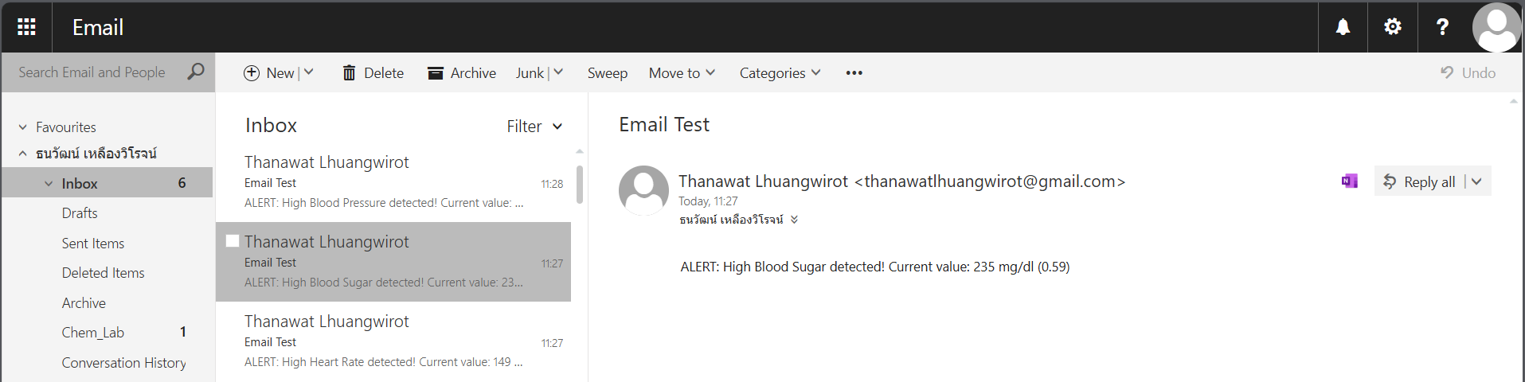
Blood Pressure
